Developer Documentation – LPS-28664

Description | wrong update date displayed in assets publisher after newer versions are deleted
LPE Path | http://issues.liferay.com/browse/LPP-3717  http://issues.liferay.com/browse/LPS-28664
Developer | Peter Borkuti
LPS Testing date | 07/18/12
Created hotfix
Hotfix testing date
Customer's Liferay version | liferay-portal-tomcat-6.1.10-ee-ga1-20120223174854827.zip
Hotfixes | liferay-hotfix-312-6110.zip  liferay-hotfix-316-6110.zip  liferay-hotfix-337-6110.zip  liferay-hotfix-340-6110.zip  liferay-hotfix-396-6110.zip  liferay-hotfix-456-6110.zip
Database | Bug is database-independent, testing with HSQL

Table of contents
Testing the fix against liferay/liferay-portal 1
Testing against liferay/liferay-portal master 2
Description of the wrong behaviour 2
Cause of the bug 4
Modifying the code 4

Testing the fix against liferay/liferay-portal
Testing date: 7/18/2012
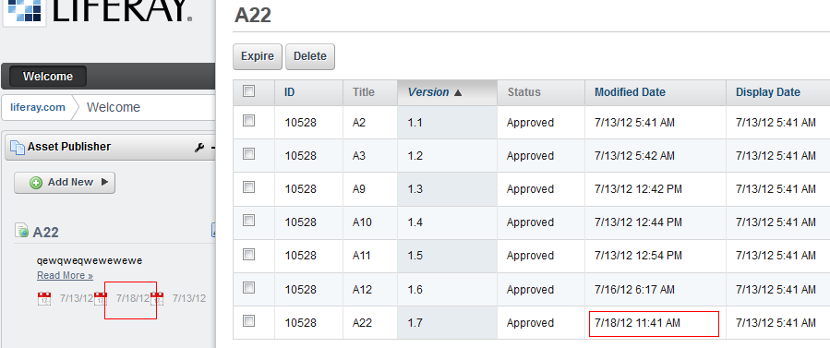
After deleting A22, the modified date in Asset publisher changes to the modification date of A12(expected behaviour):
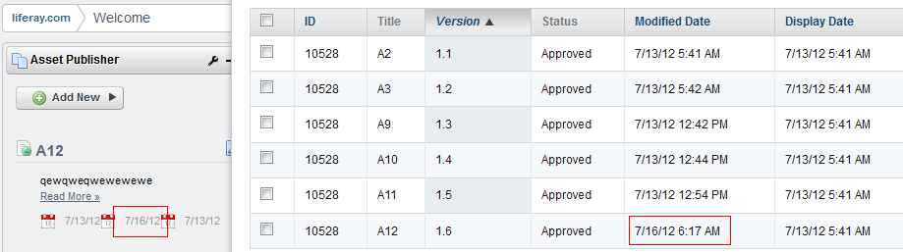

Testing against liferay/liferay-portal master
Testing date: 7/18/2012
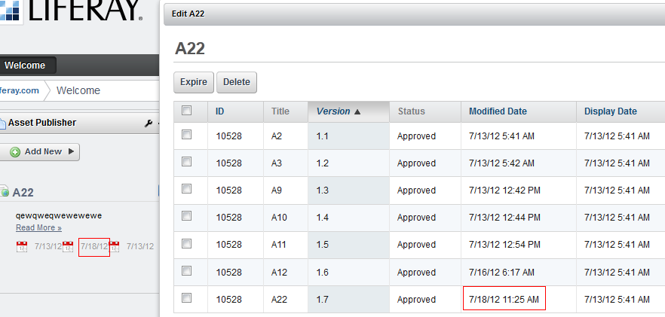

After deleting A22, the modified date in Asset publisher did not change (wrong behaviour):
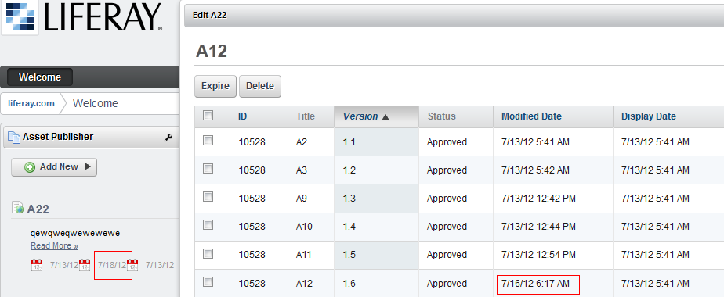

Description of the wrong behaviour

AssetEntry modified-date not appropriate.

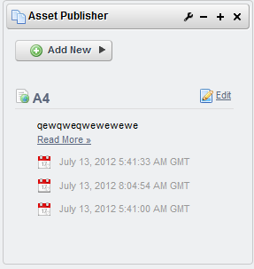
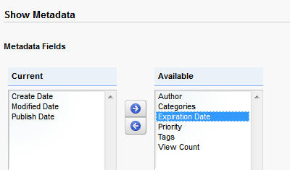
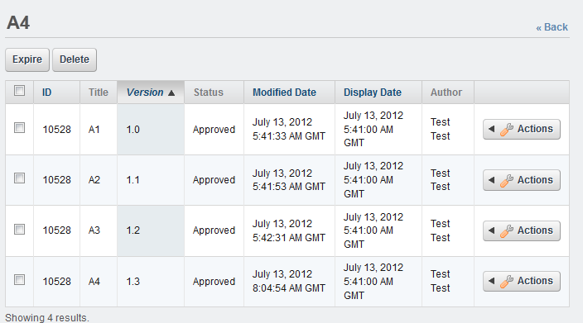

After deleting the first and the last versions:

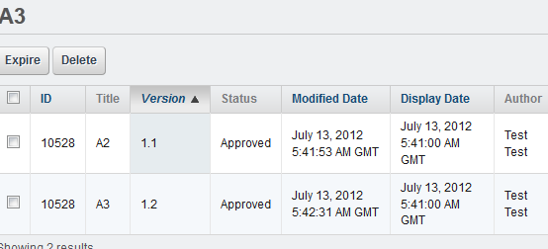

The publisher shows the same dates:
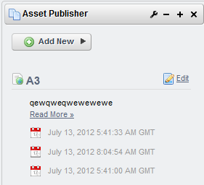
The dates above are for the A4 document.

Cause of the bug

The assetEntry's modified date not modified when assetEntry updated.
It must be set to the previous version's modifedDate.

Modifying the code
in AssetEntryLocalServiceImpl.java a new method which is very similar to the
public AssetEntry updateEntry(
String className, long classPK, Date publishDate,
Date expirationDate, boolean visible)

public AssetEntry updateEntry(
String className, long classPK, Date publishDate,
Date expirationDate, boolean visible, Date modifiedDate)
throws PortalException, SystemException {

long classNameId = PortalUtil.getClassNameId(className);

AssetEntry entry = assetEntryPersistence.findByC_C(
classNameId, classPK);

entry.setExpirationDate(expirationDate);
entry.setPublishDate(publishDate);
entry.setModifiedDate(modifiedDate);

updateVisible(entry, visible);

assetEntryPersistence.update(entry, false);

return entry;
}

in JournalArticleLocalServiceImpl.java modify the call of updateEntry

protected void updatePreviousApprovedArticle(JournalArticle article)
throws PortalException, SystemException {

List<JournalArticle> approvedArticles =
journalArticlePersistence.findByG_A_ST(
article.getGroupId(), article.getArticleId(),
WorkflowConstants.STATUS_APPROVED, 0, 2);

if (approvedArticles.isEmpty() ||
((approvedArticles.size() == 1) &&
(article.getStatus() == WorkflowConstants.STATUS_APPROVED))) {

if (article.isIndexable()) {
Indexer indexer = IndexerRegistryUtil.nullSafeGetIndexer(
JournalArticle.class);

indexer.delete(article);
}

assetEntryLocalService.updateVisible(
JournalArticle.class.getName(), article.getResourcePrimKey(),
false);
}
else {
JournalArticle previousApprovedArticle = approvedArticles.get(0);

if (article.getStatus() == WorkflowConstants.STATUS_APPROVED) {
previousApprovedArticle = approvedArticles.get(1);
}

Date[] dateInterval = getDateInterval(
previousApprovedArticle.getGroupId(),
previousApprovedArticle.getArticleId(),
previousApprovedArticle.getDisplayDate(),
previousApprovedArticle.getExpirationDate());

Date displayDate = dateInterval[0];
Date expirationDate = dateInterval[1];
Date modifiedDate = previousApprovedArticle.getModifiedDate();

assetEntryLocalService.updateEntry(
JournalArticle.class.getName(), article.getResourcePrimKey(),
displayDate, expirationDate, true, modifiedDate);

if (article.isIndexable()) {
Indexer indexer = IndexerRegistryUtil.nullSafeGetIndexer(
JournalArticle.class);

indexer.reindex(previousApprovedArticle);
}
}
}

